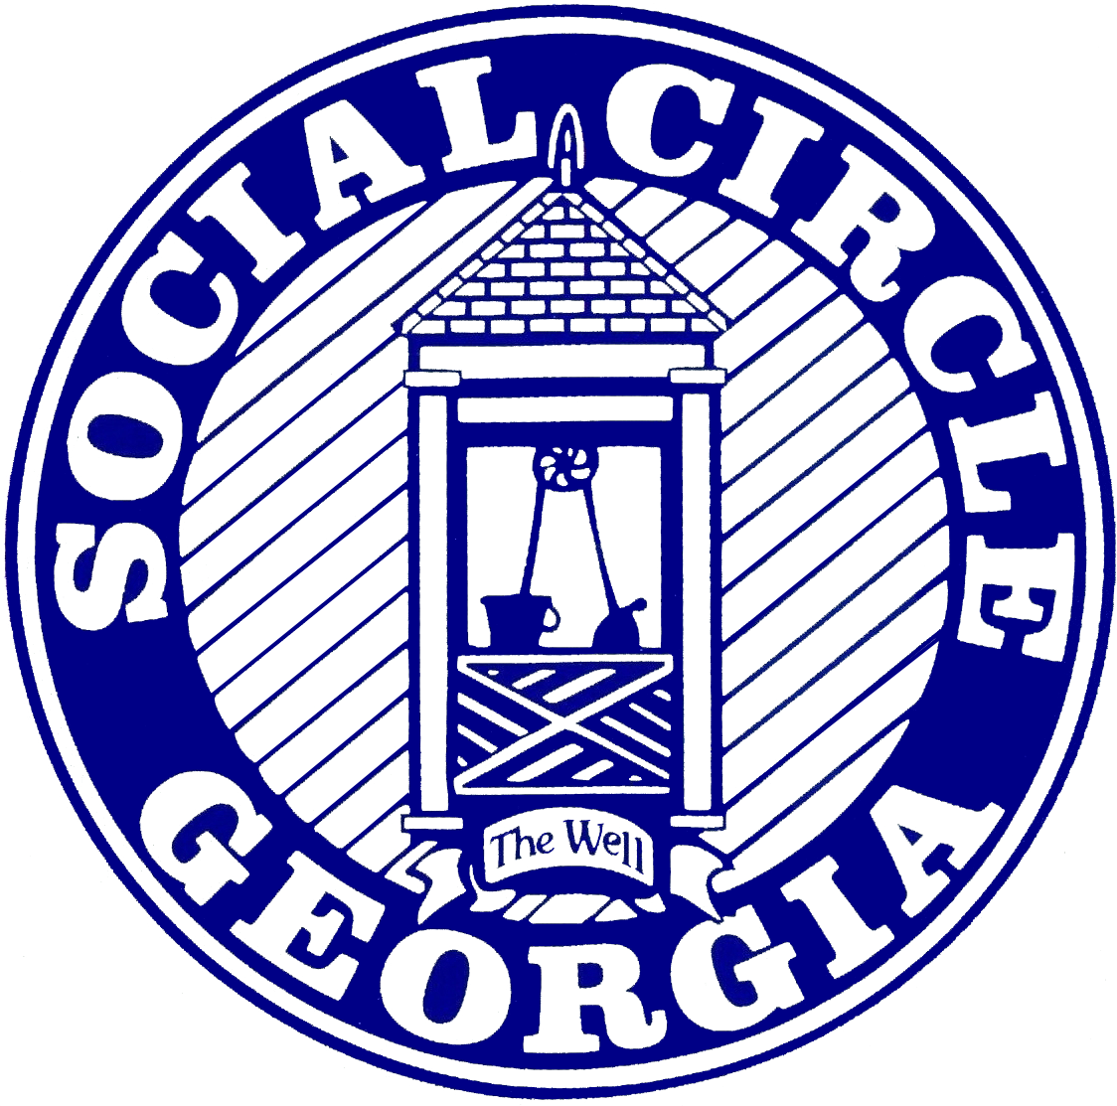

2023 WATER QUALITY REPORT

Social Circle Water System I.D. #2970002

City Hall # 770-464-2380 WTP Ph. # 770-464-2516

The City of Social Circle is committed to supplying you with the highest water quality possible. The purpose of this report is to help your understanding of drinking water safety. The City will not mail copies of this water report to each customer. Copies are available at City Hall upon request. The following data will explain where your water comes from and the processes that are used.
Social Circle’s main source is surface water drawn from the Alcovy River, four miles west of town on Social Circle-Jersey Rd. Our plant can produce one million gallons per day. The other sources are for emergencies and come from the Walton County Water and Sewage Authority with a water purchase agreement set at one-half million gallons per day and an emergency interconnect with Newton County Water Authority.
Water Department staff test and monitor the water continuously. Also, monthly samples are sent to the Georgia Department of Natural Resources Environmental Protection Division for testing at state labs. These tests ensure that proper chemical levels are maintained and that the water remains free of unwanted contaminants.
A Source Water Assessment Plan was completed by the Northeast Georgia Regional Development Center. (Website: www.negrdc.org). Most potential pollution sources within the Social Circle water supply watershed were marked as low release and low-risk potential (sewer leaks and spills, urban run-off, road crossings, agricultural operations, pipelines, oil and gas). This source assessment and protection plan can be used by Social Circle in times when emergency response is needed.
Some people may be more vulnerable to contaminants in drinking water than the general population. Immuno-compromised persons such as persons with cancer undergoing chemotherapy, persons who have undergone organ transplants, people with HIV/AIDS or other immune system disorders, some elderly, and infants can be particularly at risk from infections. These people should seek advice about the risk of infection by Cryptosporidium and other microbial contaminants available from the Safe Water Drinking Hotline (1-800-426-4791)
Drinking water, including bottled water, may be expected to contain at least insignificant amounts of contaminants. The presence of contaminants does not necessarily indicate that water poses a health risk. More information about contaminants and potential health effects can be obtained by calling EPA’s Safe Drinking Water Hotline (1-800-426-4791).
The sources of drinking water (both tap water and bottled water) include rivers, lakes streams, ponds, reservoirs, springs, and wells. As water travels over the surface of the land or through the ground, it dissolves naturally occurring minerals and, in some cases, radioactive materials, and can pick up substances resulting from the presence of animals or human activity.
Contaminants that may be present in source water before treatment include the following:
*Microbial contaminants, such as viruses and bacteria may come from sewage treatment plants, septic systems, agricultural livestock operations, and wildlife.
*Inorganic contaminants such as salts and metals which can be naturally occurring or result from urban storm runoff, industrial or domestic wastewater discharges, oil and gas production, mining, or farming.
*Pesticides and herbicides may come from a variety of sources such as agriculture, urban stormwater runoff, and residential uses.
*Organic chemical contaminants, including synthetic and volatile organic chemicals, which are by-products of industrial processes and petroleum production, and can also come from gas stations, urban stormwater runoff, and septic systems.
*Radioactive contaminants, which can be naturally occurring or be the result of oil and gas production and mining activities.
To ensure that tap water is safe to drink, EPA prescribes regulations, which limit the number of certain contaminants in water provided by public water systems. Food and Drug Administration regulations establish limits for contaminants in bottled water that provide the same protection for public health.

Definitions
*MG: Million Gallons
*MGD: Million Gallons per day
*Maximum Contaminant Level (MCL): The highest contaminant level allowed in drinking water. MCLs are set as close to the MCLGs as feasible using the best available treatment technology.
*Maximum Contaminant Level Goal (MCLG): The level of a contaminant allowed in drinking water below which there is a known or expected health risk.
*Action Level (AL): The concentration of a contaminant which if exceeded, triggers treatment or other requirements that a water system must follow.
*Treatment Technique (TT): A required process intended to reduce the contaminant level in drinking water.
*Turbidity: A measure of the cloudiness of water. We monitor turbidity because it’s a good indicator of the effectiveness of our filtration system.
*PPM: parts per million (one pound of a substance per one million pounds of water)
N/A: non-applicable
NTU: Nephelometric Turbidity Units (measures cloudiness of water)

REGULATED CONTAMINANTS DETECTED 2023
SUBSTANCE | MCL (MRDL) | MCLG (MRDLG) | SC Water System Max | Detected Range | Is Water Safe? | Typical Source of Contaminant
Microbiological Contaminates
FILTER TURBIDITY | TT= 0.3 NTU 95% of Samples <0.3 NTU | 0 100% | 0.09 | .02 - .090 | YES | Agriculture, Geology
Total Coliform Bacteria | 5% Samples Positive | 0% Positive | 0% | 0% | YES | Naturally occurring
Total Organic Carbon | TT | N/A | 3.6 | 1.1 - 3.6 | YES | Naturally occurring
Disinfection & Disinfection By-Products
TOTAL TRIHALOMETHANES 4 QTR. AVERAGE | 80 ppb | N/A | 80 ppb | 1.6 - 96.5 | YES | Treatment process by-product
HALOACETIC ACID 4 QRT. AVERAGE | 60 ppb | N/A | 38.0 ppb | 8.9 - 25 | YES | Treatment process by-product
Chlorite | 0.8 | N/A | 0.46 | .10-.46 | YES | Treatment process by product
CHLORINE | 4 ppm | 4 ppm | 2.2 ppm | 1.1 - 2.2 | YES | Water additive used to control microbes
Inorganic Contaminates
FLUORIDE | 4 ppm | 4 ppm | 1.2 | .68 - 1.2 | YES | Water additive which promotes strong teeth
NITRATE | 10 ppm | 10 ppm | 0.29 | .29 ppm | YES | Erosion of Natural Deposits
Substance | Action Level | MCLG | SC Water System 90% Percentile | Number of Samples Above Action Level | Is Water Safe? | Typical Source of Contaminate
COPPER | 1300 ppb | 1300 ppb | 620 ppb | 0 | YES | Household piping
LEAD | 15 ppb | 0 ppb | 2.8 ppb | 0 | YES | Household piping

A Community Partnership: We encourage public interest and participation in our community’s decisions affecting water. Here’s how you can help: Immediately report any problems you experience or witness to our Customer Service Department. Our representatives can help determine the source of the problem and respond with a course of action. Any inquiries about your water quality should be directed to Robbie Groves (678-710-5279). (Spanish translation available if needed).

Increasing populations increase great demands on available water supplies. In addition, droughts have been more common in the last 20 years and are decreasing our available source and groundwater. Conservation is necessary if we are to maintain our current way of life. In the future communities will be forced to increase water efficiency by conserving water and reusing and treatment of wastewater. Conservation will help protect this valuable resource. Water, sewer, and energy bills decrease when water is used more efficiently.
Lead and Drinking Water: If present, elevated levels of lead can cause serious health problems, especially for pregnant women and young children. Lead in drinking water is primarily from materials and components associated with service lines and home plumbing. SCWD is responsible for providing high-quality drinking water but cannot control the variety of materials used in plumbing components on the customer side of the meter. When your water has been sitting for several hours, you can minimize the potential for lead exposure by flushing your tap for 30 seconds to 2 minutes before using water for drinking or cooking. If you are concerned about lead in your water, you may wish to have your water tested. Information on lead in drinking water, testing methods, and steps you can take to minimize exposure is available from the Safe Drinking Water Hotline or at http://www.epa.gov/safewater/lead
